|  |  |  |  |  |  |
| --- | --- | --- | --- | --- | --- |
| First Name | **Last Name** | **Re.nber** | **Department** | **Level** | **Compus** |
| **Uwase** | **Gasana shallon** | **221016536** | **BIT** | **2** | **GIKONDO** |

**QUIZES MISSED IN JAVA**

***JAVA CONTROL STATEMENT:***

* *JAVA IF-ELSE STATEMENT:*

**EXPRIMENT 1;**

public class ndizeye {

public static void main(String[] args) {

int marks=15;

if(marks>10){

System.out.print(" The marks is greater than =7");

}

}

}

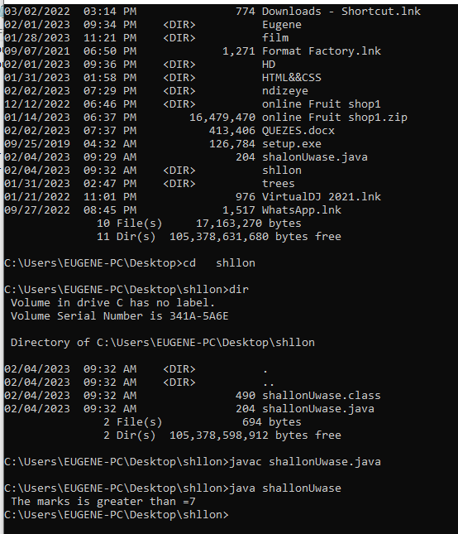

**EXPRIMENT 2;**

public class UwaseGasanaShallon {

public static void main(String[] args) {

int number=45;

String output=(number%2==0)?"even number":" the enterd number is :=odd number";

System.out.println(output);

}

}

**Out put:**

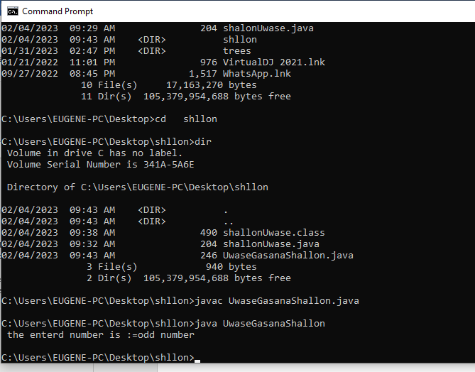

**EXPRIMENT 3;**

**public class student {**

**public static void main(String[] args) {**

**int marks=65;**

**if(marks<50){**

**System.out.println("fail try again");**

**}**

**else if(marks>=50 && marks<60){**

**System.out.println(" you have grade D ");**

**}**

**else if(marks>=60 && marks<70){**

**System.out.println(" you have grade C");**

**}**

**else if(marks>=70 && marks<80){**

**System.out.println(" you have grade B");**

**}**

**else if(marks>=80 && marks<90){**

**System.out.println(" you have grade A ");**

**}else if(marks>=90 && marks<100){**

**System.out.println(" A+ grade");**

**}else{**

**System.out.println("Invalid!");**

**}**

**}**

**}**

**OUT PUT:**

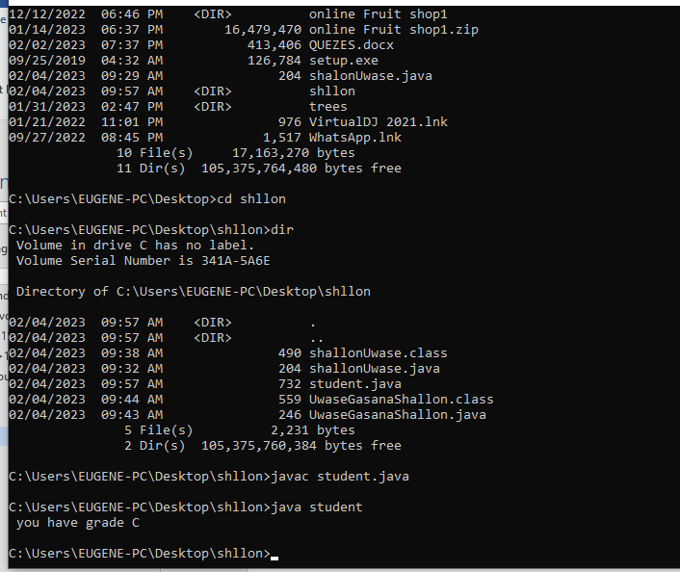

JAVA OBJECT CLASS:

**EXPRIMENT 1;**

**class Calculation{**

**void fact(int n){**

**int fact=2;**

**for(int i=2;i<=n;i++){**

**fact=fact*i;**

**}**

**System.out.println("factorial is "+fact);**

**}**

**public static void main(String args[]){**

**new Calculation().fact(5);//calling method with anonymous object**

**}**

**}**

**OUT PUT:**

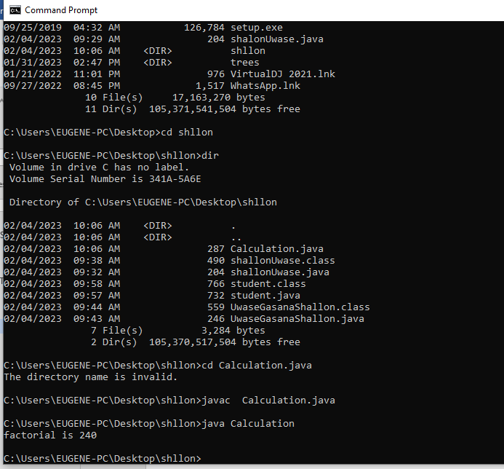

**EXPRIMENT 2;**

class Rectangle{

int length;

int width;

void insert(int l, int w){

length=l;

width=w;

}

void calculateArea(){System.out.println(length*width);}

}

class Rectangle1{

public static void main(String args[]){

Rectangle r1=new Rectangle();

Rectangle r2=new Rectangle();

r1.insert(11,5);

r2.insert(30,15);

r1.calculateArea();

r2.calculateArea();

}

}

**OUT PUT:**

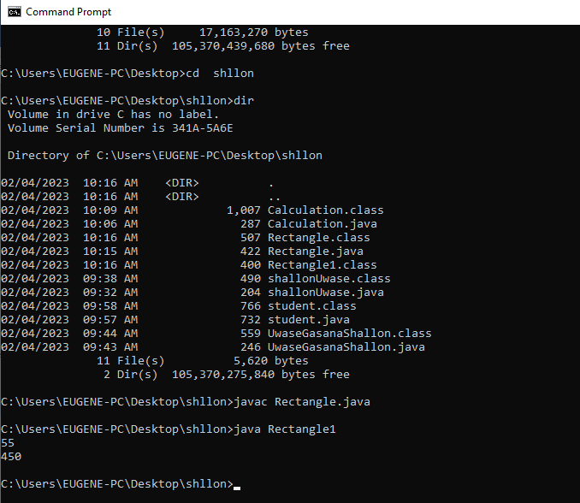

**EXPRIMENT 3;**

class Student{

int id;

String name;

}

class TestStudent1{

public static void main(String args[]){

Student s1=new Student();

Student s2=new Student();

s1.id=102;

s1.name="UwaseGasanaShallon";

s2.id=109;

s2.name="GasanaShallon";

System.out.println(s1.id+" "+s1.name);

System.out.println(s2.id+" "+s2.name);

}

}

**OUT PUT IS:**

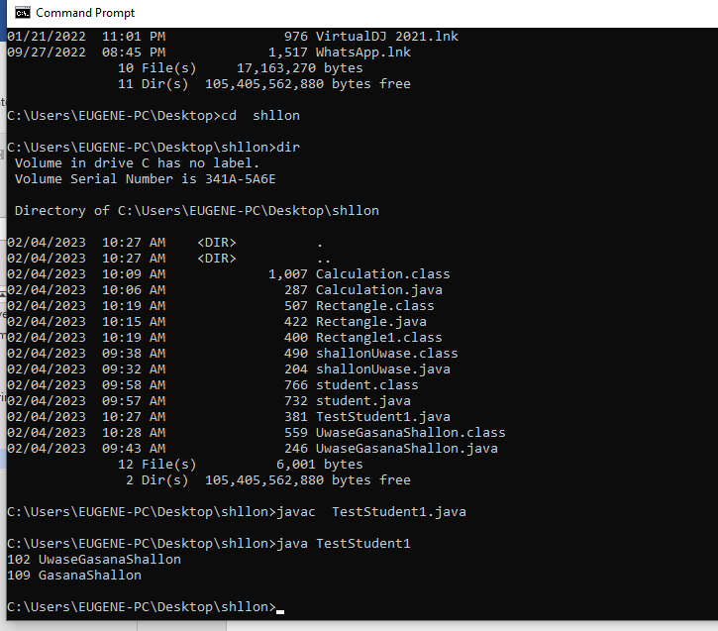

***JAVA INHERTANCE:***

***EXPRIMENT 1;***

class Animal{

void eat(){System.out.println("eating avocadoes...");}

}

class Dog extends Animal{

void bark(){System.out.println("barking in %%%");}

}

class Cat extends Animal{

void meow(){System.out.println("meowing off %%%");}

}

class TestInheritance{

public static void main(String args[]){

Cat c=new Cat();

c.meow();

c.eat();

}}

**OUT PUT IS:**

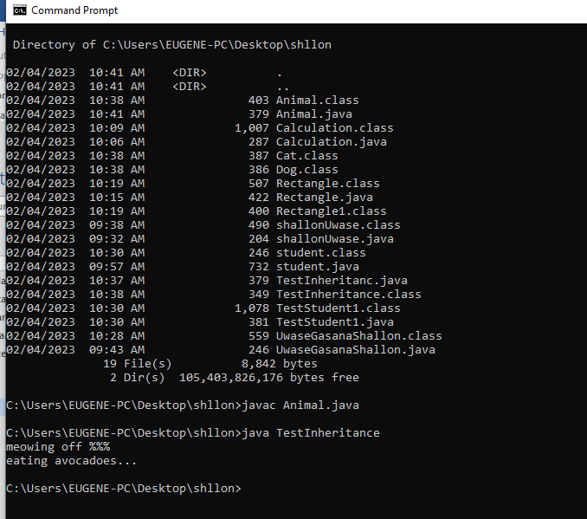

***EXPRIMENT 2;***

class Employee{

float salary=4120000;

}

class Programmer extends Employee{

int bonus=120000;

public static void main(String args[]){

Programmer p=new Programmer();

System.out.println("Programmer salary is:"+p.salary);

System.out.println("Bonus of Programmer is:"+p.bonus);

}

}

**OUT PUT:**

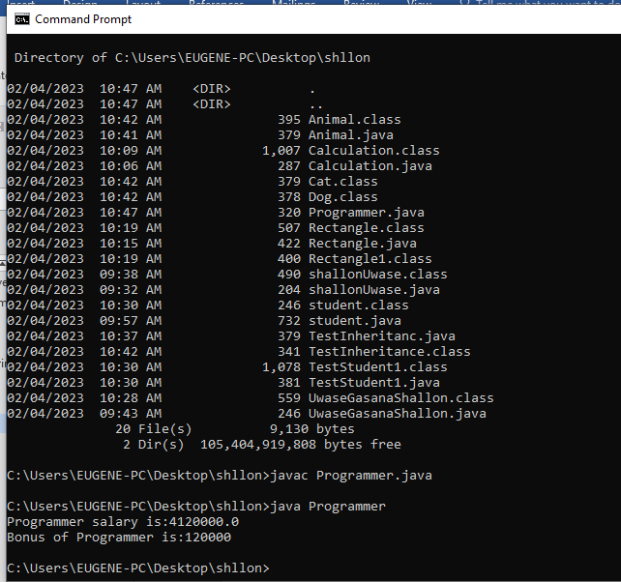

**EXPRIMENT 3;**

class Animals1{

void eat(){System.out.println("MOVING");}

}

class Dog extends Animal{

void bark(){System.out.println("RUNNING OUT");}

}

class TestInheritance12{

public static void main(String args[]){

Dog d=new Dog();

d.bark();

d.eat();

}}

**OUT PUT:**

